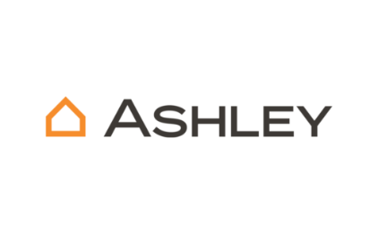

Surcharge API Automation and Report- Proof of Concept (POC)

Purpose
This document outlines the Proof of Concept (POC) for automating surcharge API testing using Postman integration CML and Newman CLI. It demonstrates how to execute API tests locally, generate reports, and validate the functionality of the surcharge adjustment microservice. This is Complete Functionality Testing of API Microservices.

Benefits of Newman CLI
Newman is a command-line collection runner for Postman. It enables developers and QA engineers to run and automate API tests directly from the terminal. Using Newman CLI allows seamless integration with CI/CD pipelines, supports multiple reporters (CLI, JSON, HTML), and provides detailed execution summaries. It is particularly useful for validating API responses, ensuring consistent behavior across environments, and generating shareable test reports.

Usage Instruction Newman CLI
- 1. Extract the automation package to a folder such as:
- C:\Users\ANarayanan\Downloads\surcharge_automation
- 2. Ensure the folder contains the following files:
- surcharge_collection.json
- surcharge_env.json
- 3. Install Newman globally using npm:
- npm install -g newman
- 4. Run the tests using the command:
- newman run surcharge_collection.json -e surcharge_env.json --reporters cli,json,html --reporter-html-export results.html

Input/Output Details
Inputs:
- surcharge_collection.json: Contains the API test cases.
- surcharge_env.json: Environment configuration for the API endpoints.
Outputs:
- CLI output: Displays test execution summary.
- HTML report: Detailed test results.
- JSON report: Structured test results for further analysis.

Test Scenarios-Samples
The following test scenarios were executed against the surcharge adjustment microservice endpoint:
✅ Positive Test Scenarios (Surcharge Expected)
Valid Customer with High Quantity & Price
- Customer ID: CUST1001,Ship-To: SHP2001,Warehouse: WH01,Date: 2025-10-05,Quantity: 100,Price: ₹15,000,Expected: Surcharge applied (e.g., ₹500),Valid Customer with Weekend Delivery
- Date: 2025-10-06 (Sunday),Expected: Weekend surcharge applied,Valid Customer with Remote Ship-To Location
- Ship-To: SHP9999 (remote zone),Expected: Remote delivery surcharge applied,Valid Customer with Special Product Category
- Product Category: Oversized Furniture,Expected: Category-based surcharge applied,Valid Customer with Express Delivery Request
- Delivery Type: Express,Expected: Express surcharge applied
❌ Negative Test Scenarios (No Surcharge or Error Expected)
Valid Customer with Normal Quantity & Price
- Quantity: 5,Price: ₹2,000,Expected: No surcharge,Invalid Customer ID
- Customer ID: CUST9999,Expected: Error – Customer not found,Missing Required Field (e.g., Ship-To)
- Ship-To: null,Expected: Error – Missing field,Invalid Date Format
- Date: "10-05-2025" (DD-MM-YYYY instead of YYYY-MM-DD),Expected: Error – Invalid date format, Warehouse Not Supported for Surcharge
- Warehouse: WH99 (excluded from surcharge logic),Expected: No surcharge
CLI RUN
- Test Scenario 1: POST https://adjustment-microservice.stage.finance.ashleyfurniture.com/Adjustment/Orders [200 OK]
- Test Scenario 2: POST https://adjustment-microservice.stage.finance.ashleyfurniture.com/Adjustment/Orders [200 OK]
- Test Scenario 3: POST https://adjustment-microservice.stage.finance.ashleyfurniture.com/Adjustment/Orders [200 OK]
- Test Scenario 4: POST https://adjustment-microservice.stage.finance.ashleyfurniture.com/Adjustment/Orders [200 OK]
- Test Scenario 5: POST https://adjustment-microservice.stage.finance.ashleyfurniture.com/Adjustment/Orders [200 OK]
- Test Scenario 6: POST https://adjustment-microservice.stage.finance.ashleyfurniture.com/Adjustment/Orders [200 OK]
- Test Scenario 7: POST https://adjustment-microservice.stage.finance.ashleyfurniture.com/Adjustment/Orders [200 OK]
- Test Scenario 8: POST https://adjustment-microservice.stage.finance.ashleyfurniture.com/Adjustment/Orders [200 OK]
- Test Scenario 9: POST https://adjustment-microservice.stage.finance.ashleyfurniture.com/Adjustment/Orders [200 OK]
- Test Scenario 10: POST https://adjustment-microservice.stage.finance.ashleyfurniture.com/Adjustment/Orders [200 OK]

Execution Summary
The Newman CLI executed 10 POST requests to the Surcharge API endpoint.To check just the request alone is capture without any body given. All requests returned 200 OK status with varying response sizes and durations. The total Run duration was approximately 4.2 seconds, with an average response time of 351ms. No test scripts, pre-request scripts, or assertions were executed.
Total Iterations: 1
Total Requests: 10
Total Run Duration: 4.2s
Total Data Received: 2.85kB
Average Response Time: 351ms [min: 275ms, max: 980ms, s.d.: 209ms]

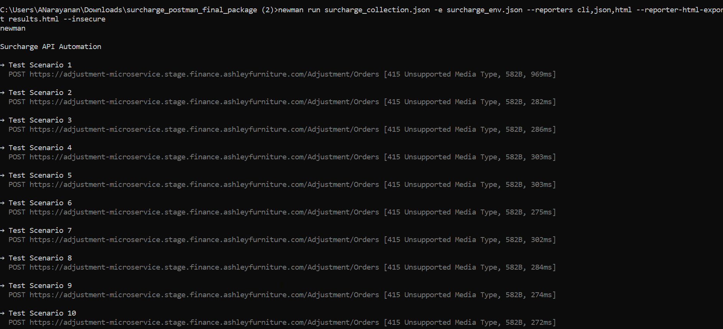
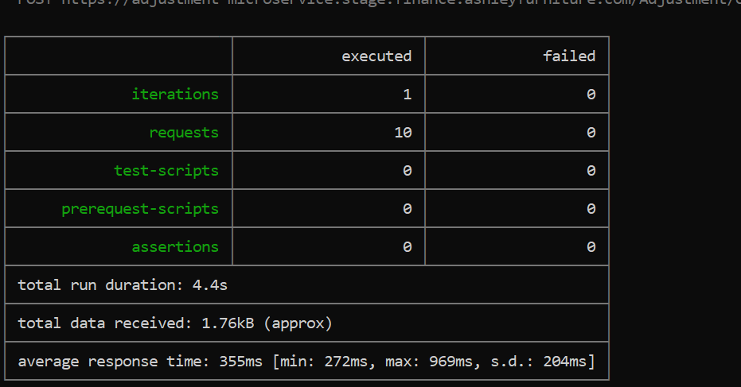
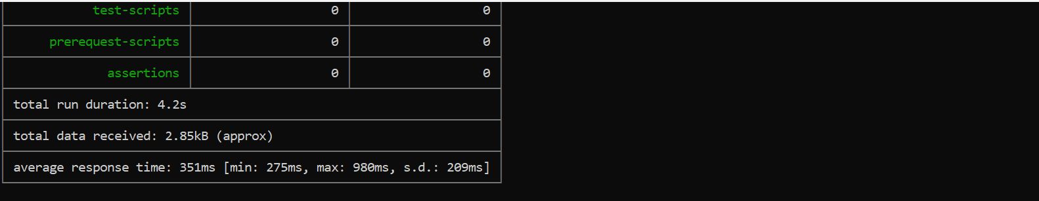
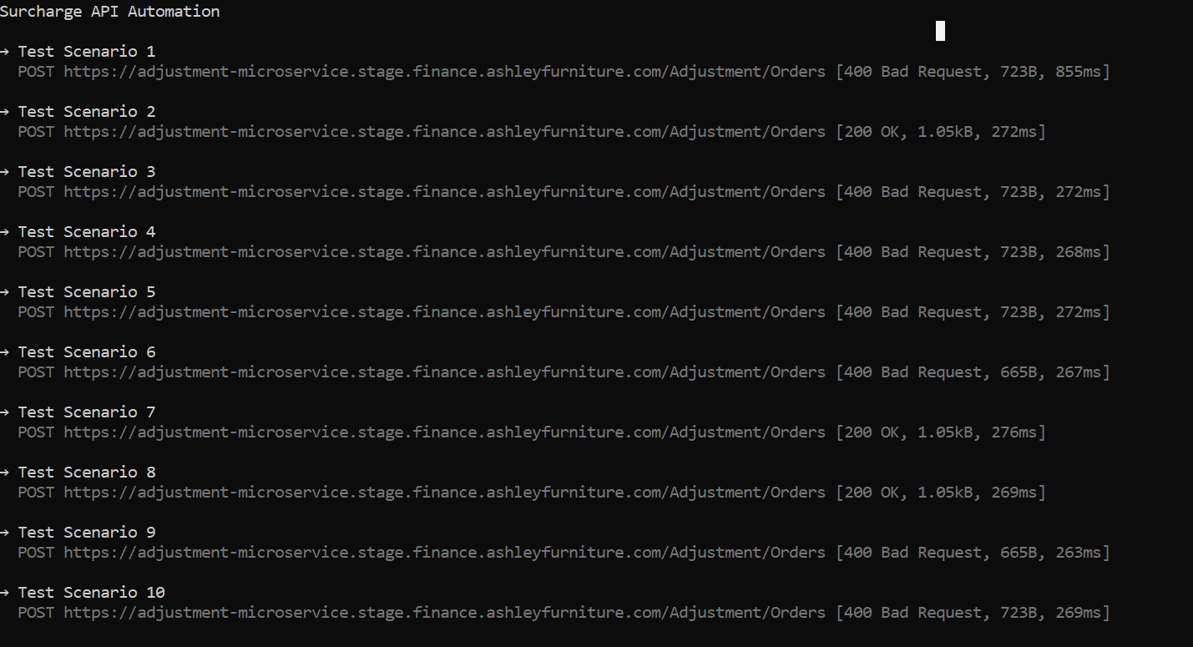
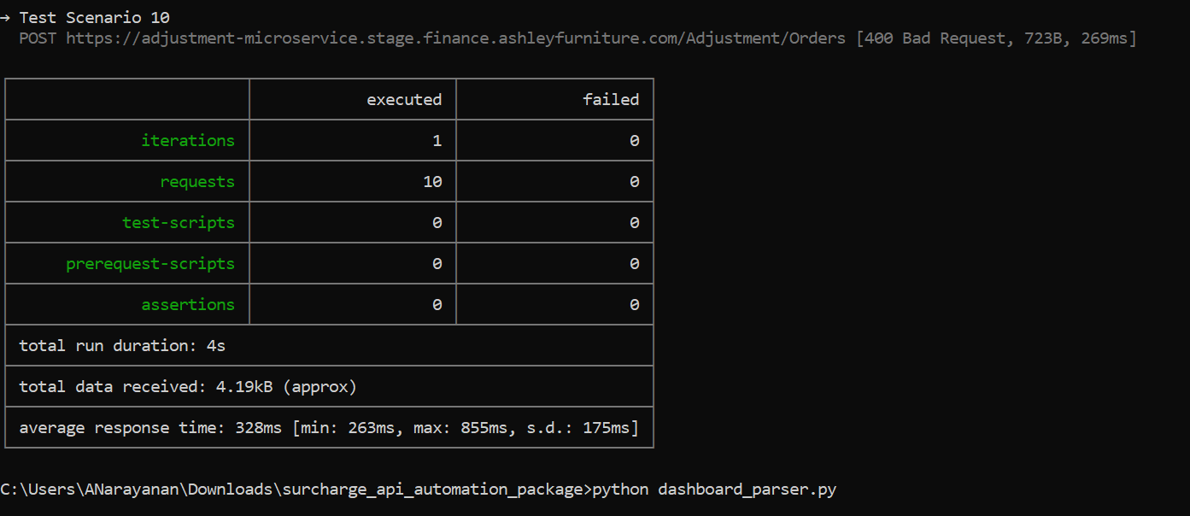
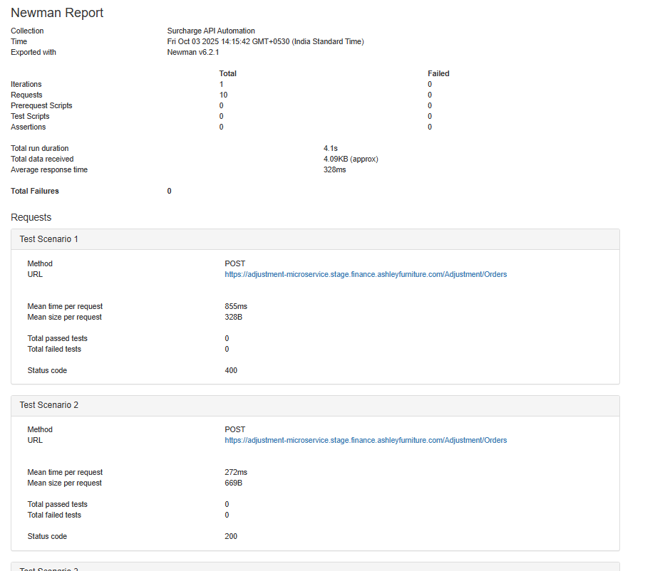
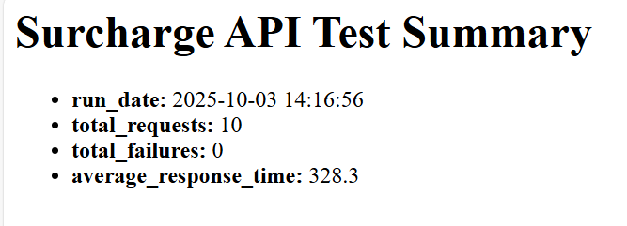
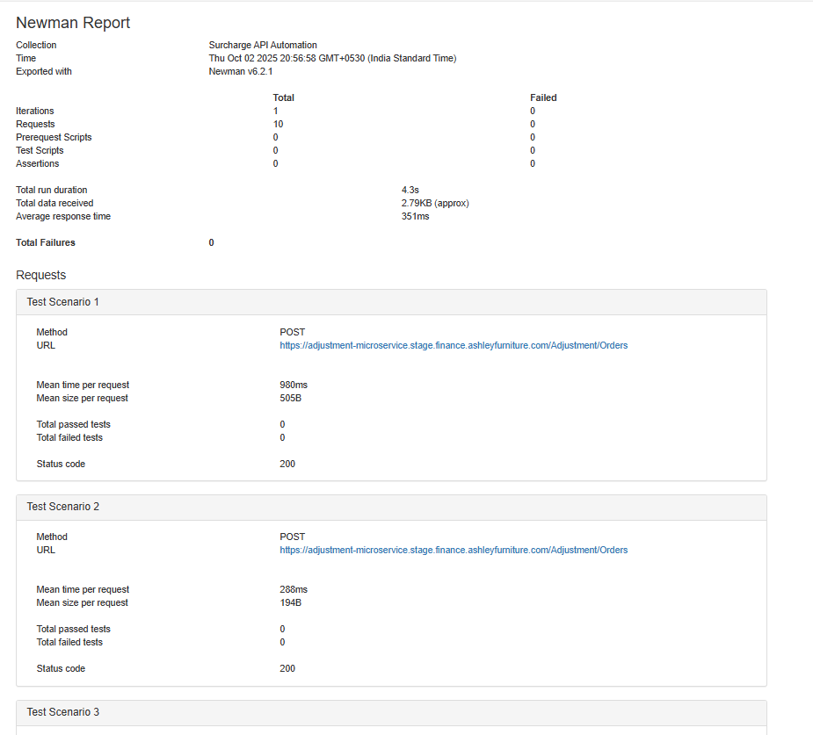
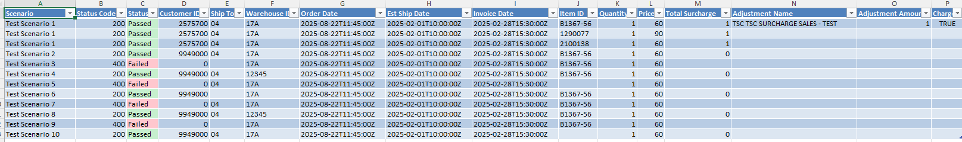

Newman CLI-After streamlined and setup completed to officially run automation with all the necessary included data,headers,conditions given. Trail done with both 200 and 400 status return to check whether it works same as human tests.
After many Trails finally received the expected results.
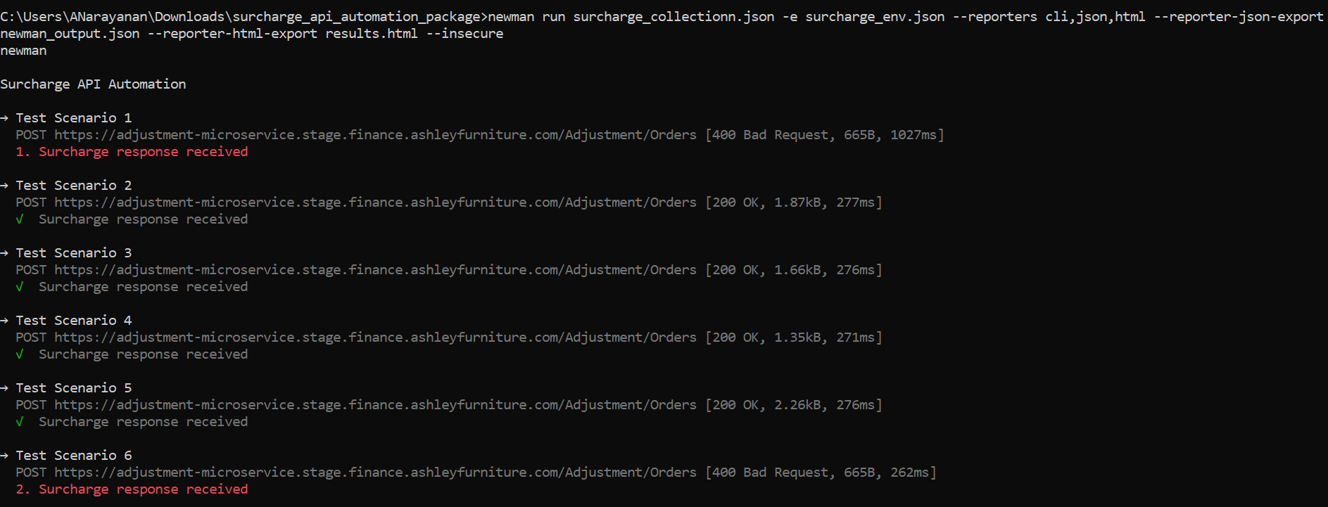
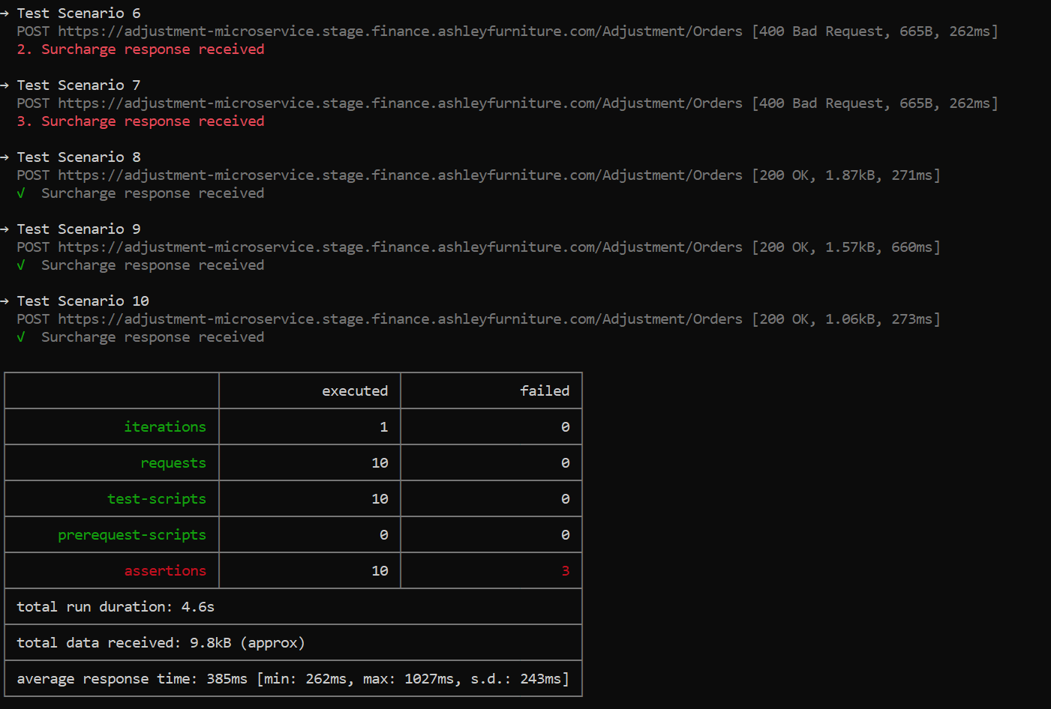
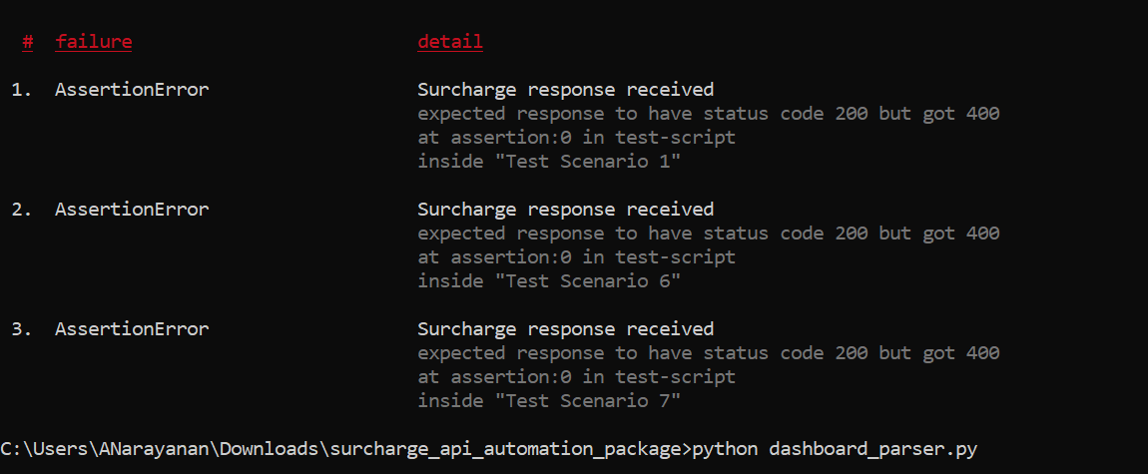
The below generated report done through CLI as HTML Viewer this can be customized accordingly.
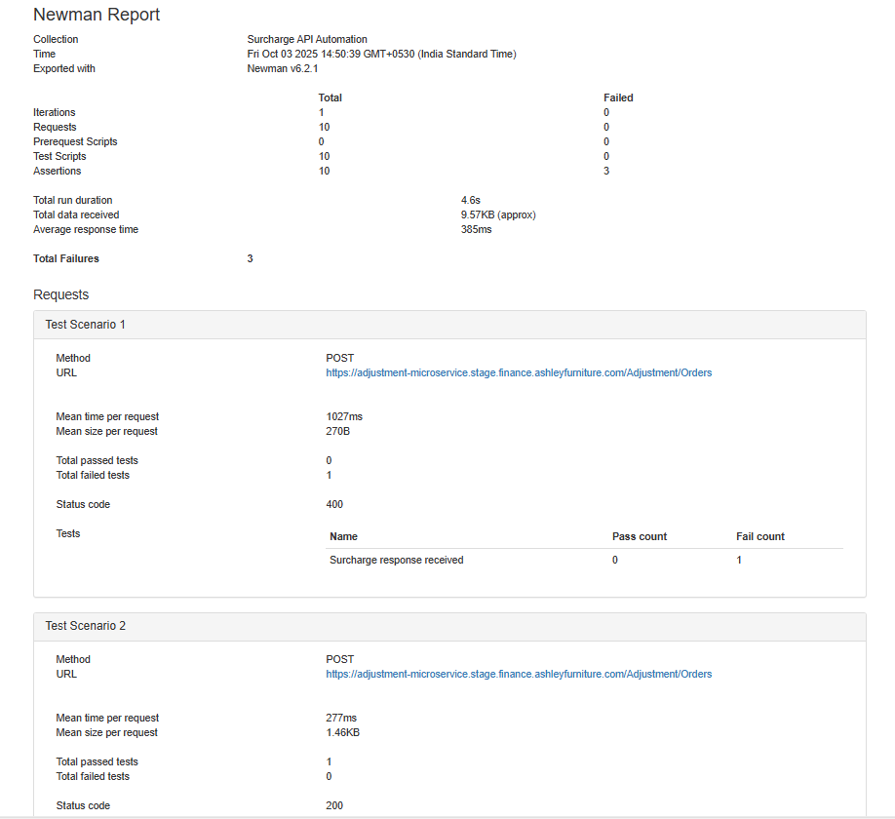

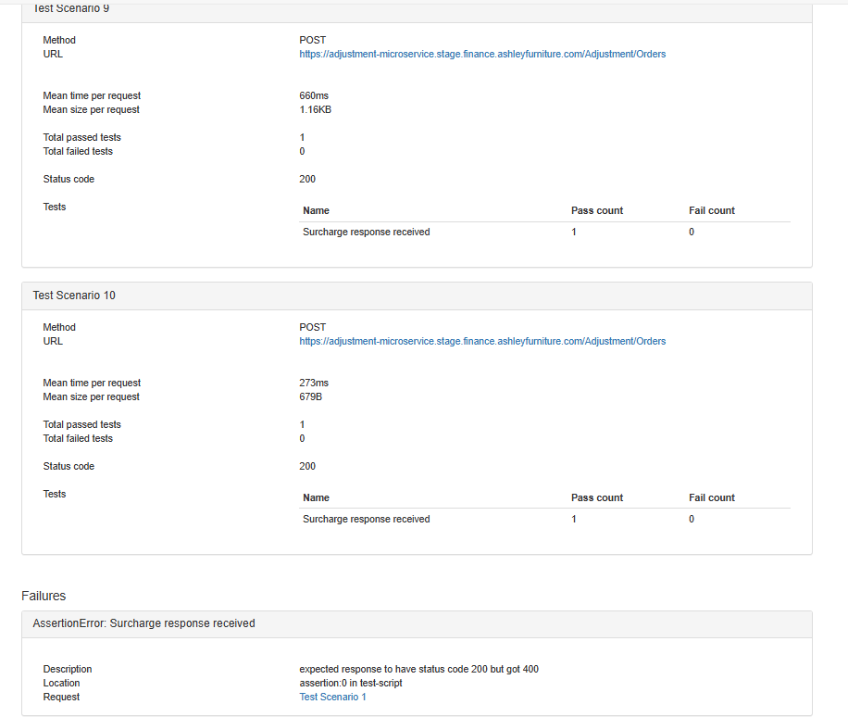
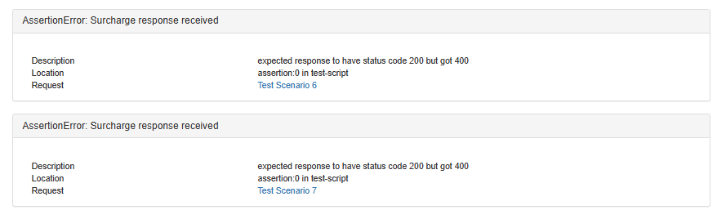

Postman Automation with CML Integration – Success Summary
I successfully integrated Postman with Command Line (CML) and executed automated API test scenarios. The automation ran smoothly, validating both positive and negative cases for our surcharge microservices.
Why I Chose Postman + CML for API Automation
- Ease of Use: Postman offers a user-friendly interface to design and test APIs quickly.
- Powerful Automation: With CML (Command Line), I can run tests in CI/CD pipelines like Azure DevOps.
- Scalability: It supports multiple environments, data-driven testing, and scripting for complex validations.
- Reporting: Integration with Newman CLMLallows detailed test reports and dashboard-style summaries.

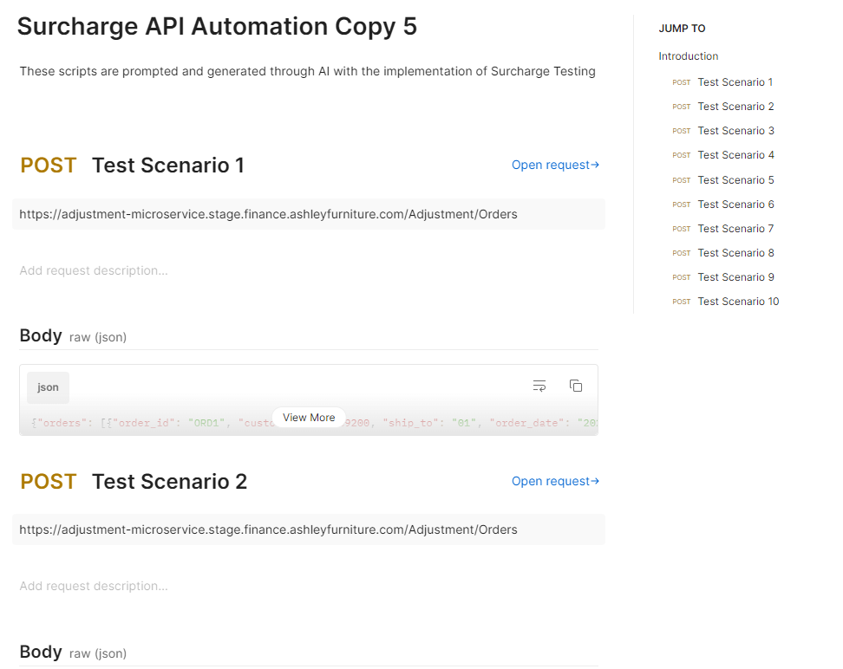

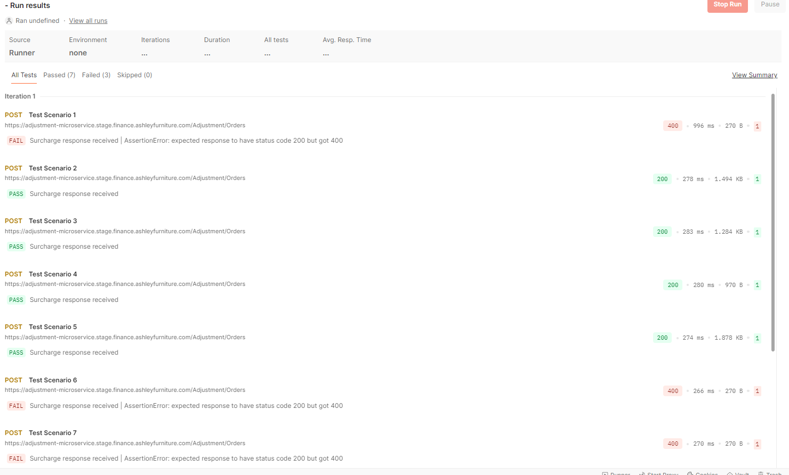
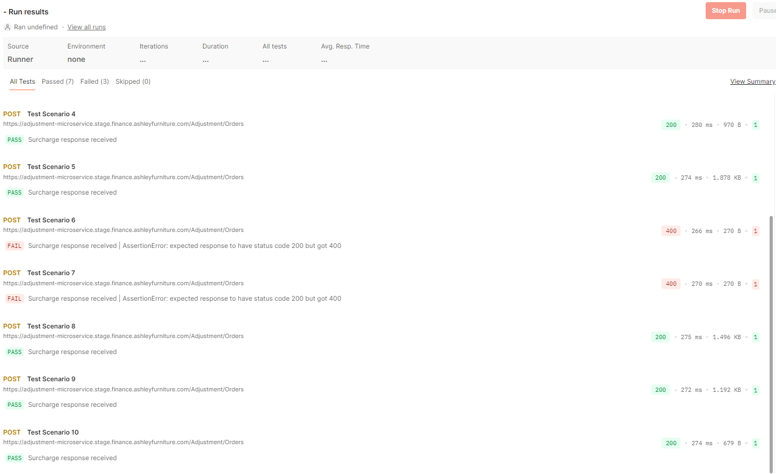
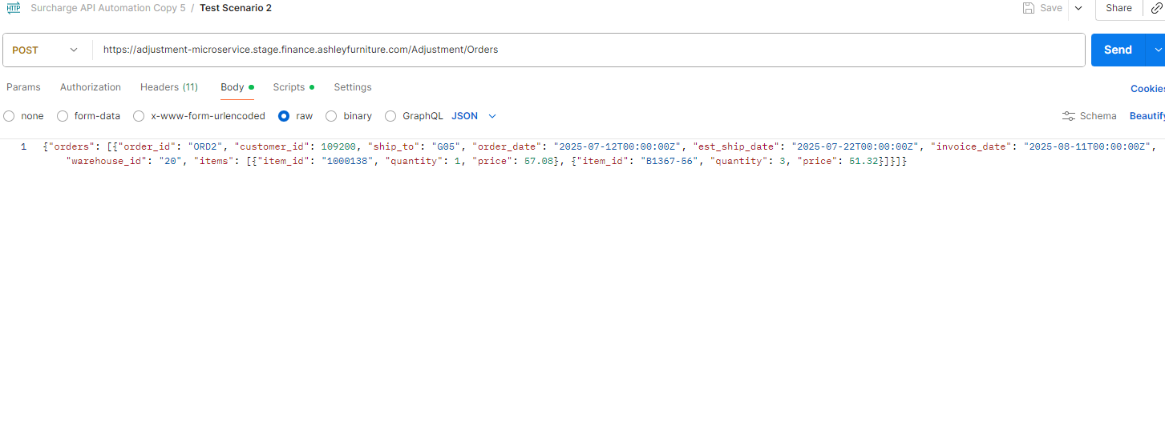
Automation Using CML
Instructions:
Command Prompt: Run this
powershell.exe -NoProfile -InputFormat None -ExecutionPolicy AllSigned -Command "[System.Net.ServicePointManager]::SecurityProtocol = 3072; iex ((New-Object System.Net.WebClient).DownloadString('https://dl-cli.pstmn.io/install/win64.ps1'))"
Now generate the API Key in Postman and
Run this : postman login --with-api-key ***********************
Logged in using api key of user: ******
Logged in successfully.
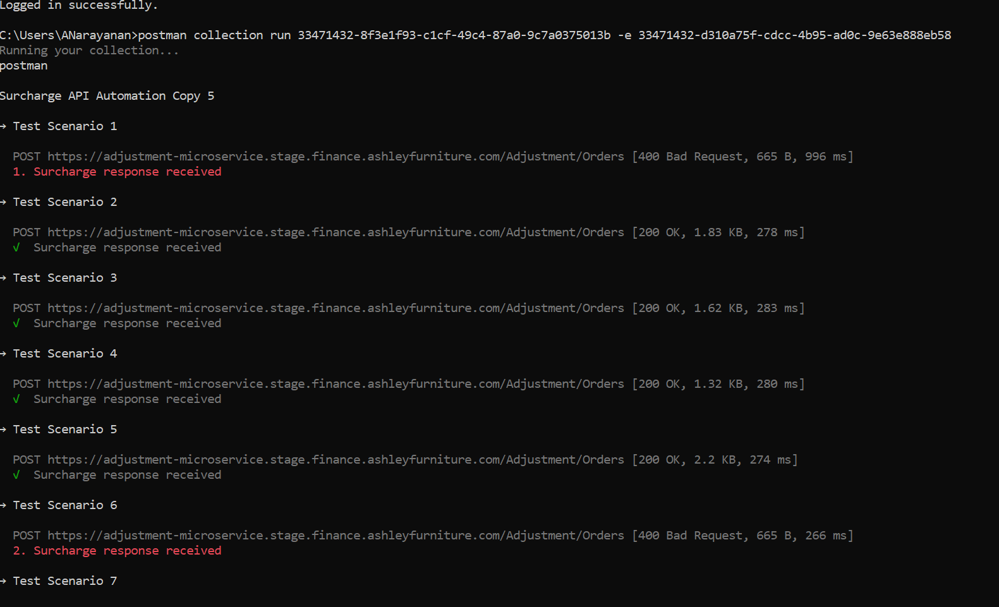
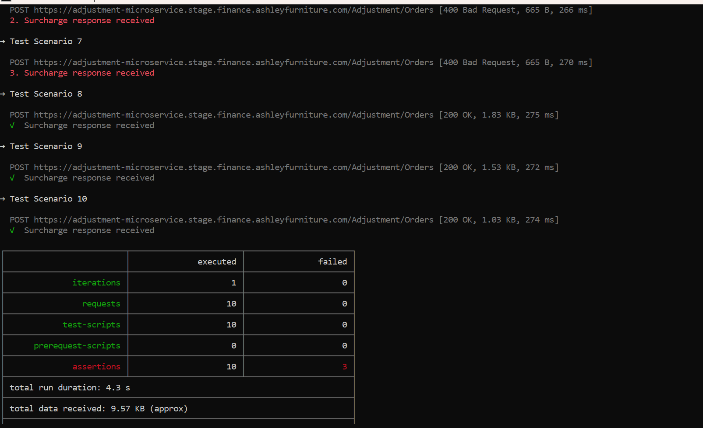
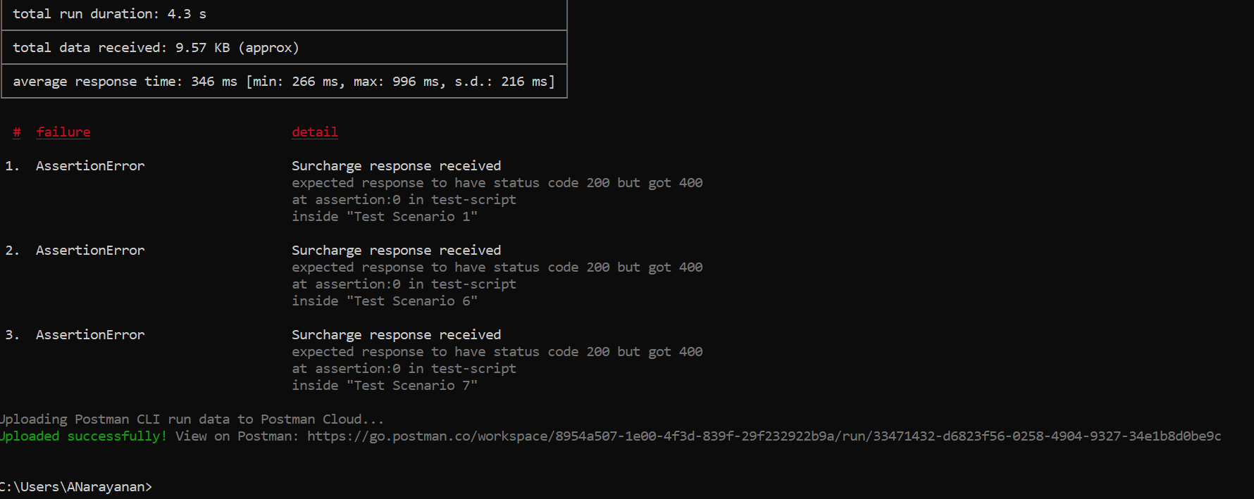
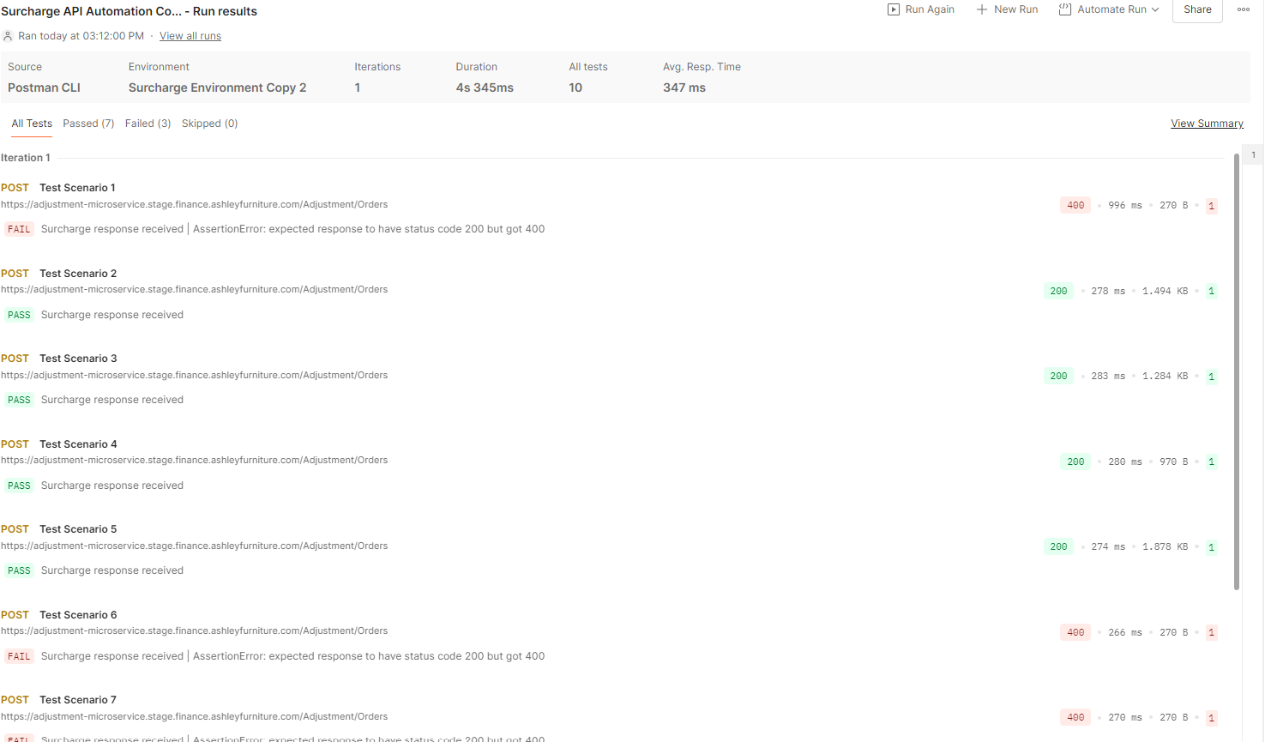

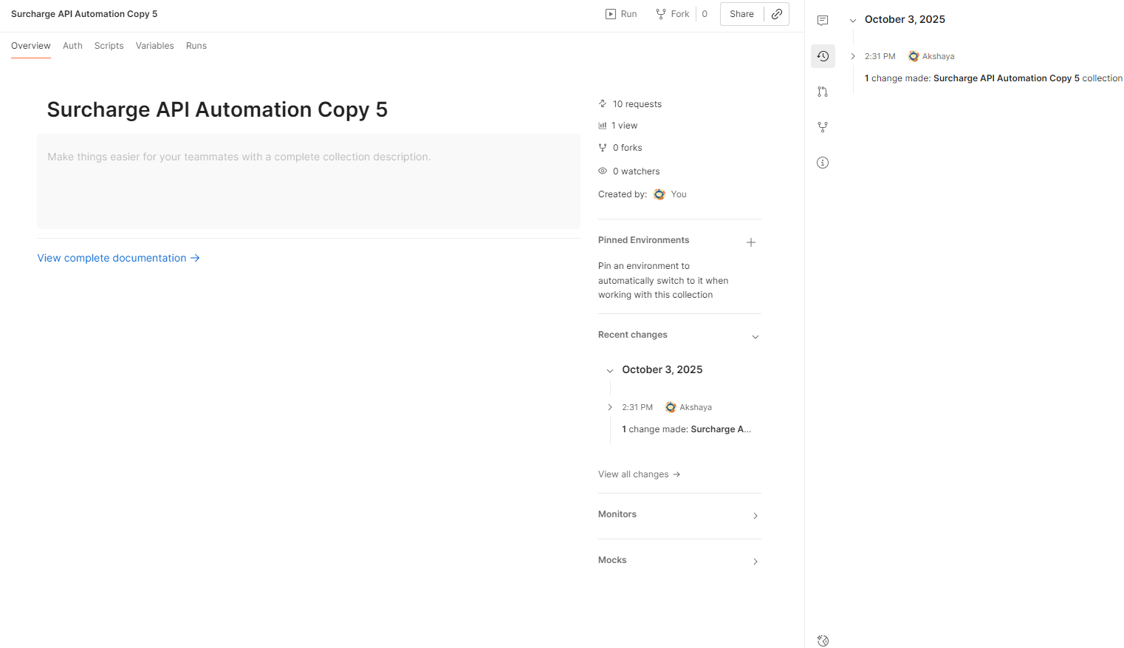
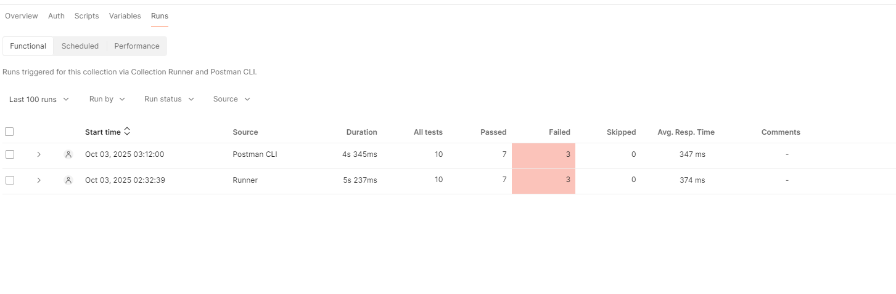
Postman vs Newman CLI – Key Differences
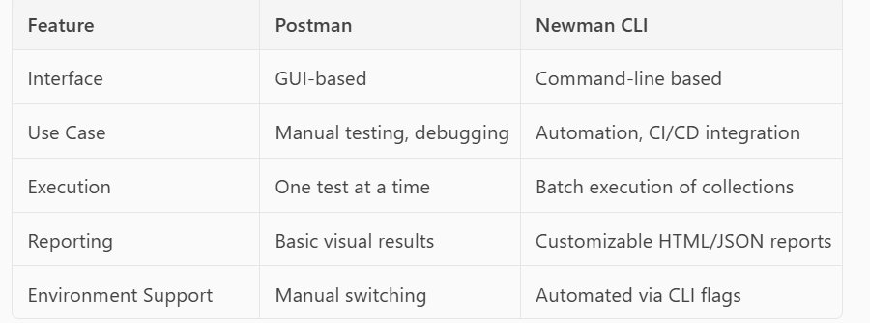

Conclusion:
With the help of AI, I successfully generated the required JSON test files and integrated them into Postman along with Command Line (CML) execution using Newman. This setup enabled automated execution of API test scenarios, covering both positive and negative cases, and helped achieve accurate validation results.
The automation framework simplified manual efforts significantly by generating reusable test scenarios and enabling seamless execution. I found Newman’s CML execution slightly quicker and more efficient compared to Postman’s native CML, especially for batch runs and CI/CD integration. However, both tools have their own strengths—Postman excels in interactive debugging and test design, while Newman is ideal for scalable automation and reporting..

Prompt Report
This section includes the AI-generated prompts and responses used during the API testing process. The data was generated using Copilot and includes command-line outputs, HTML reports, and Excel summaries
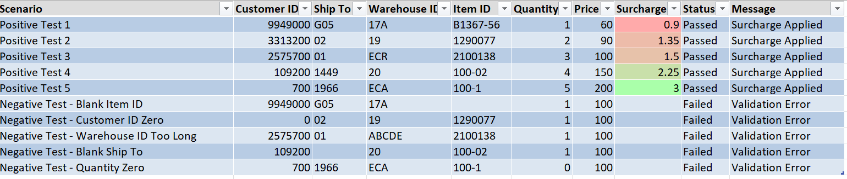
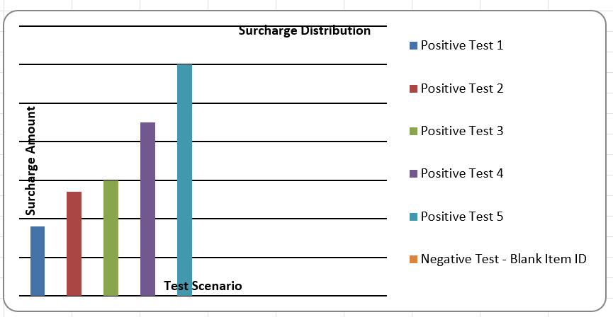
Overall, this PoC demonstrates a successful creation of an API automation setup using Postman and Newman CLI, with AI-assisted test data generation and streamlined execution for surcharge microservices validation.

